Faculty of Science, Engineering and Technology

Interface Design and Development

Custom Web Application Development Guide (Supplementary)

# Overview

This document aims to guide students in preparing the custom web application proposal for the initial submission.

|  |  |
| --- | --- |
| **Purpose:** | Demonstrate that you can develop and prepare a comprehensible and appropriate proposal prior development of the custom web application. |
| **Task:** | Create your own web application that recognizes accessibility, wireframe design and design document. |
| **Time:** | This task should be completed before week 8. |
| **Resources:** | * Nil |

**Note**: To prevent disappointment/being rejected, you are advised to prepare a comprehensive and genuine proposal.

Submission Details

You must submit the following files to Blackboard under Proposal Submission Link:

* The proposal in Word Document
* This task is to be signed off by your Lecturer / Convener

# Proposal Outline

Below are the expected information to be included in your custom web application proposal.

1. Project title – *Define a relevant, meaningful and WOW project name*
2. User Story / Problem Statement (1/2 page) – *Why do you want to develop this web app?*
3. Data preparation/collection *- Where to get the data, expected amount of data?*
4. Functional requirements / use cases - *What can the web application do?*
5. Comply and demonstrated appropriate use of features integrated in the web development frameworks. – *Did you applies what you learned in this unit into practice?*
6. Proposed & brief description of external library(ies) / framework(s) integration *– What are the external library(ies) which could supplement and add extra features to your web application? Introduce and explain how it going to work.*
7. References of external library(ies) / framework(s) / idea integration *– Explain and elaborate where did you get to know this libraries/framework/idea/concept/inspiration from. What makes you adopted this external libraries/framework/idea/concept?*
8. Web app wireframes in both desktop & mobile (portrait & landscape) views *– How does the web app are going to look like?*

# Development Priority & Considerations

High

Distinction

Distinction

# Proposal Assessment Process

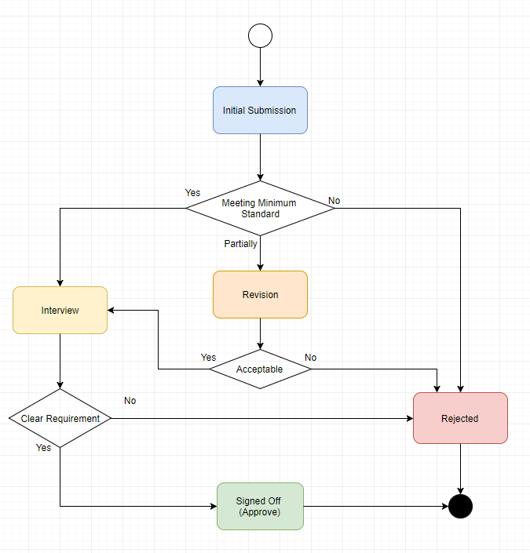

**Final Custom Web Application Development Checklist & Evidences**

You are required to demonstrate your competency of Single Page Web Application development using Bootstraps and AngularJS effectively by applying the concepts, topics and techniques learned in this unit and with external sources.

|  |  |  |  |
| --- | --- | --- | --- |
| **ID** | **Criteria** | **Fulfilled (✓)** | **Evidence** |
| 1 | Effectively design and develop the single page application using Bootstraps’s Grid Layout with proper nested row-column layout |  |  |
| 2 | Enable menu toggle in mobile view |  |  |
| 3 | Effectively applies at least four other Bootstraps components i.e. carousel / jumbotron / table / accordion / sliders/ glyphicons / modal box / etc… |  |  |
| 4 | Single page application is well rendered in both mobile (portrait and landscape) and desktop view |  |  |
| 5 | Effective use of AngularJS’s common directive & filters [with little code duplication – HD Only] |  |  |
| 6 | Effective use of AngularJS’s controller |  |  |
| 7 | Effective use of AngularJS’s route and ng-view |  |  |
| 8 | Effective use of AngularJS’s custom filter and custom directive |  |  |
| 9 | Effective use of AngularJS’s Service / Provider / Factory |  |  |
| 10 | Proper forms and client side validation |  |  |
| 11 | Appropriately store webpage content/data using array or JSON object and render to the view with proper data-binding techniques |  |  |
| 12 | **[HD Only]** Backend integration with sustainable persistent data storage & management. |  |  |
| 13 | **[HD Only]** Appropriate and proper modularization to promote web application expansibility and scalability |  |  |
| 14 | Appropriately integrated with external library(ies) with references |  |  |
| 15 | Webpage must pass HTML validation with no errors and warnings |  |  |
| 16 | Webpage must comply with WCAG 1.0 (Level A) with no known problem – use Accessibility Check (achecker) |  |  |
| 17 | **[Optional]** Webpage must comply with WCAG 2.0 (Level AA with no potential problem – use Accessibility Check (achecker) |  |  |
| 18 | Appropriate section for acknowledgement and reference to the original website. |  |  |
| 19 | The developed web application effectively resolve user pain points / problems |  |  |
| 20 | **[HD Only]** Journal of the web development ideas |  |  |

*\*\* This table is to be included in your final custom web app report and portfolio*